**Design Document**

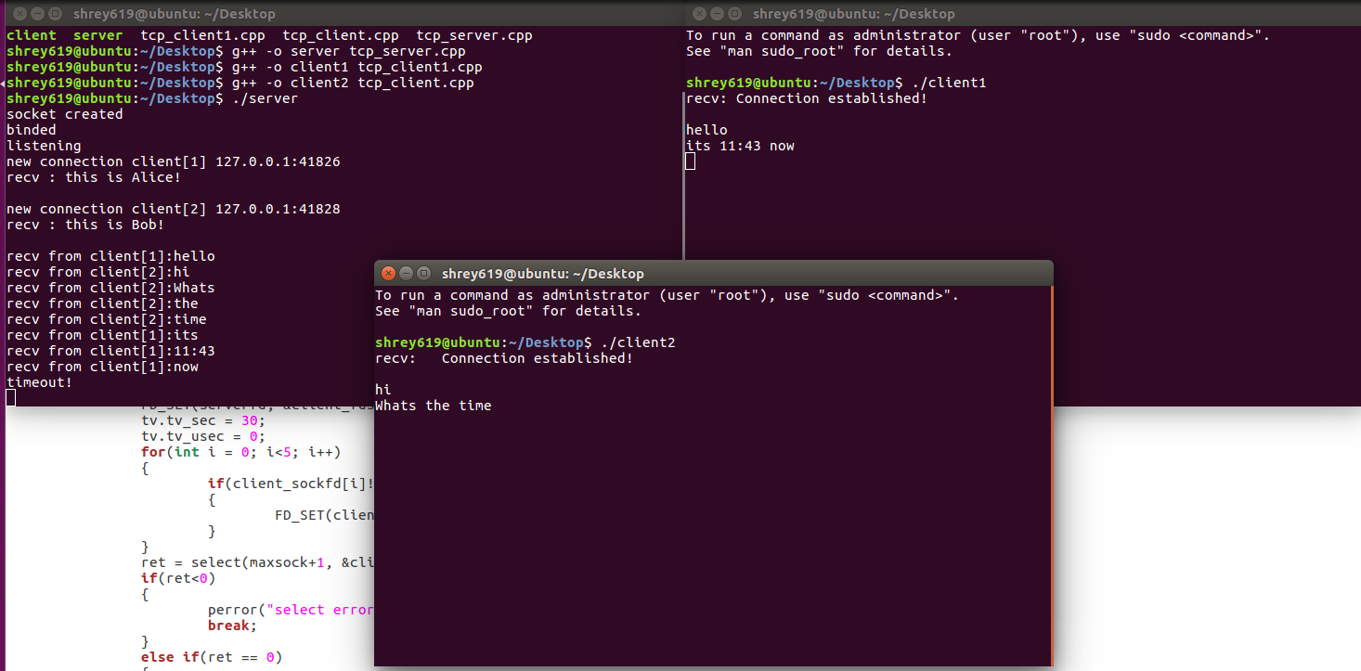

Screenshot of both Alice and Bob communicating through server

Conditions where code might:

* The server is not on and client tries to connect.
* Client is unaware of server’s port number / ip.
* If the port is already in use the server won’t start.

If above screenshots client[1] is Alice and client[2] Bob.